**EXPERIMENT NO. 08**

# CONFIGURATION OF DYNAMIC HOST CONFIGURATION PROTOCOL (DHCP) SERVER USING CISCO PACKET TRACER

**EXPERIMENT NO. 08**

**AIM: -** To configure dynamic host configuration protocol (DHCP) server using Cisco Packet Tracer.

**OBJECTIVES:**

1. To automatically assign IP addresses to the end devices in a network.

**SOFTWARE:** Cisco Packet Tracer.

**SCENARIO:**

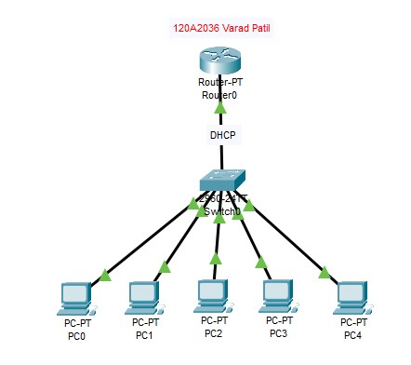

**CONFIGURATION OF FASTETHERNET0/0 INTERFACE OF Router0**

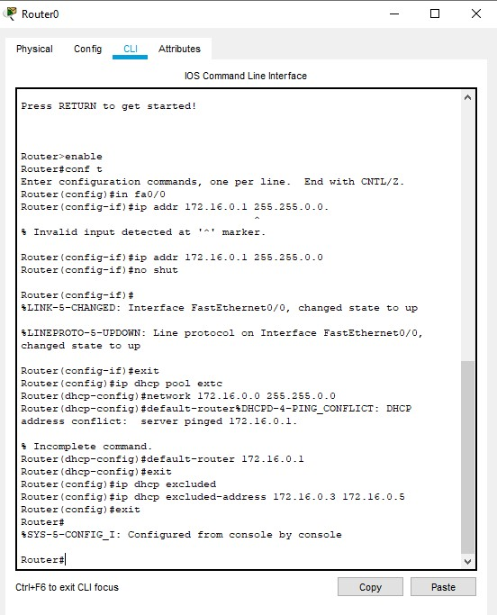

**By clicking on the DHCP command, the IP addresses are automatically assigned to the PCs and they are as follows:-**

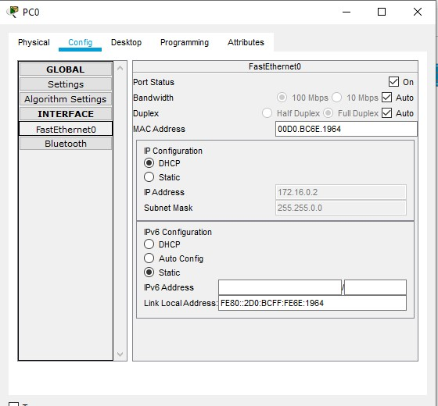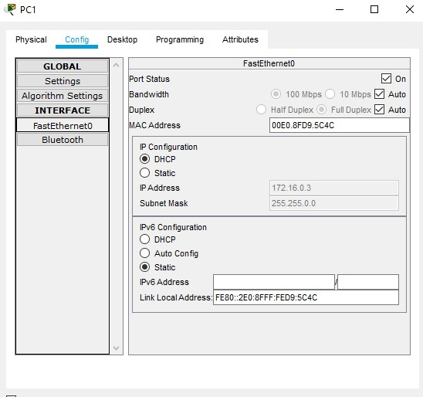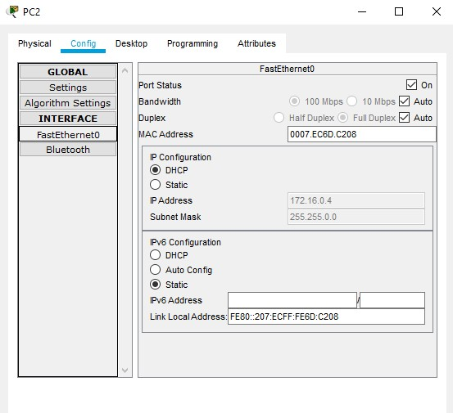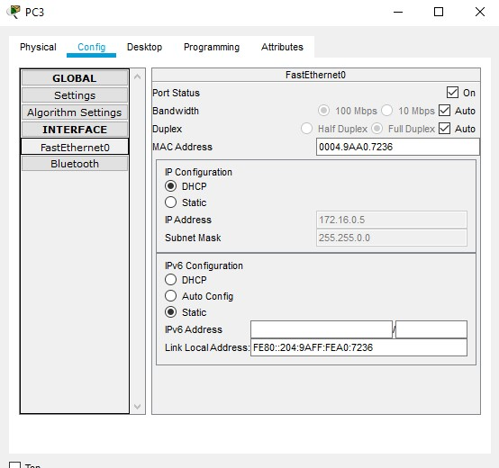

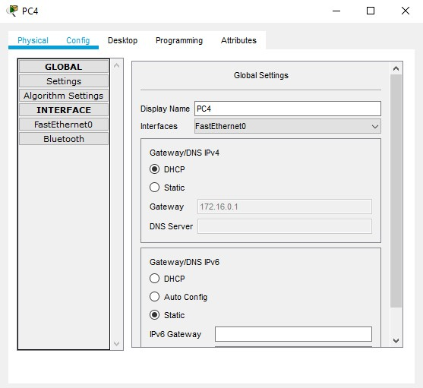

By using the **ip dhcp excluded-address command**, we select the range of those IP addresses which should not be assigned to the PCs.

**For e.g.** The IP address of PC2 previously was **172.20.0.4**. After using the ip dhcp excluded-address command, the new IP address assigned to PC2 is **172.20.0.8**

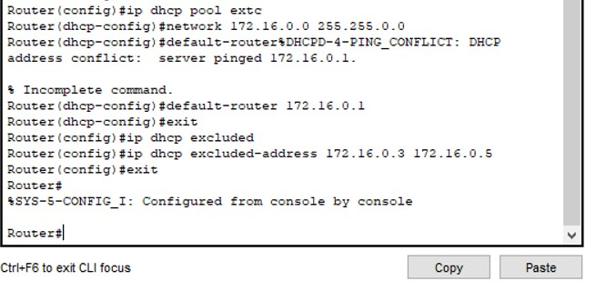

**PING RESPONSE:**

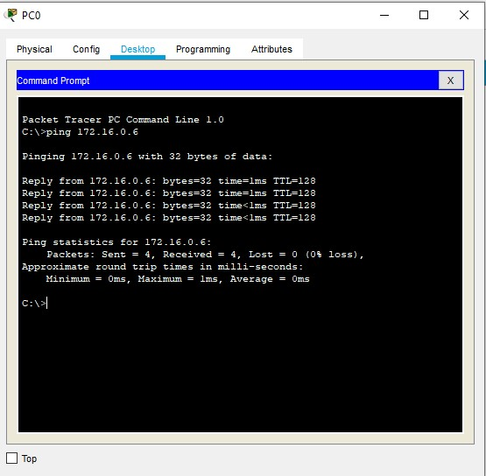

**CONCLUSION:**

Configuration of dynamic host configuration protocol (DHCP) server using Cisco was performed successfully. Ip address were assigned to all pcs and student were able to exclude ip address.